Jawan Pakistan
Free Artificial Intelligence Ramadan Camp Course
Prompt Engineering Assignment #4
Question 1: Zero-Shot Prompting
Write a simple instruction asking the Al to summarize a story or decide if a review is positive or negative. Do not give the Al any examples to follow.
Answer 1: Zero-Shot Prompting
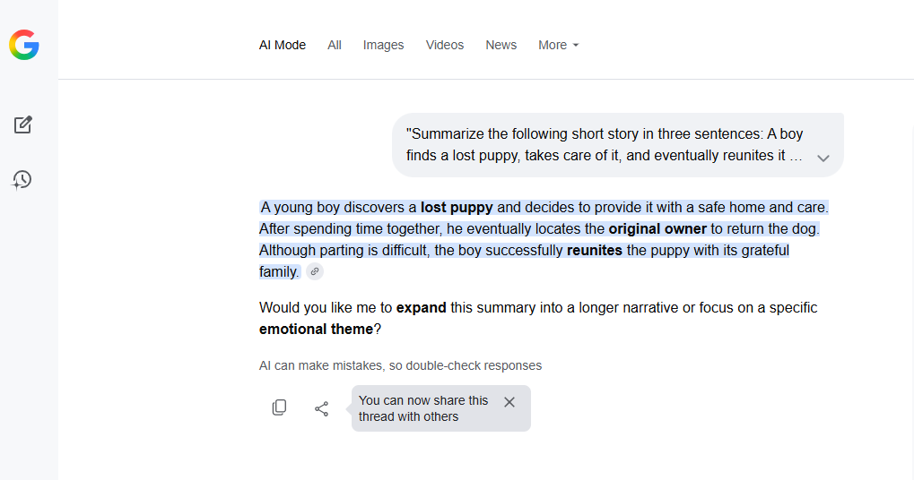

Question 2: One-Shot Prompting
Create a prompt that shows the Al how to do a task by giving it only one example. For instance, show it how to change "John Doe" to "Doe, John," and then ask it to do the same for a new name.
Answer 2: One-Shot Prompting
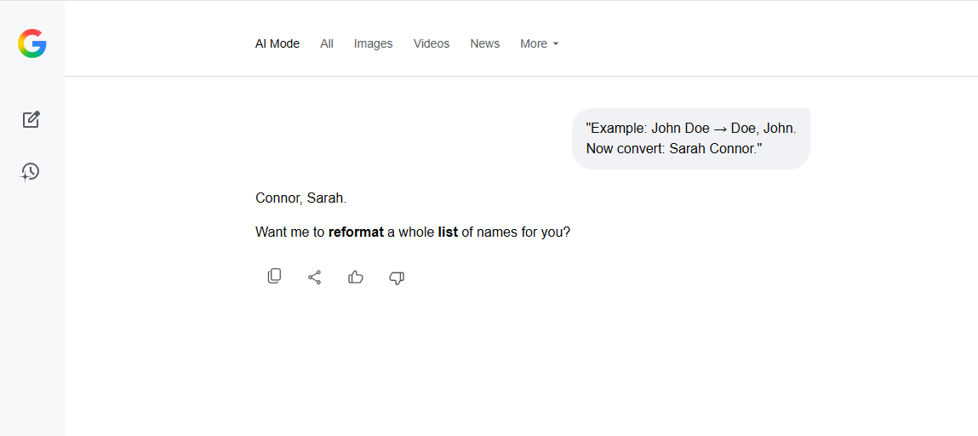
Question 3: Few-Shot Prompting
Write a prompt that gives the Al three examples of a specific writing style (like a poem or a short product description). Then, ask the Al to write a new one using that same style.
Answer 3: Few-Shot Prompting
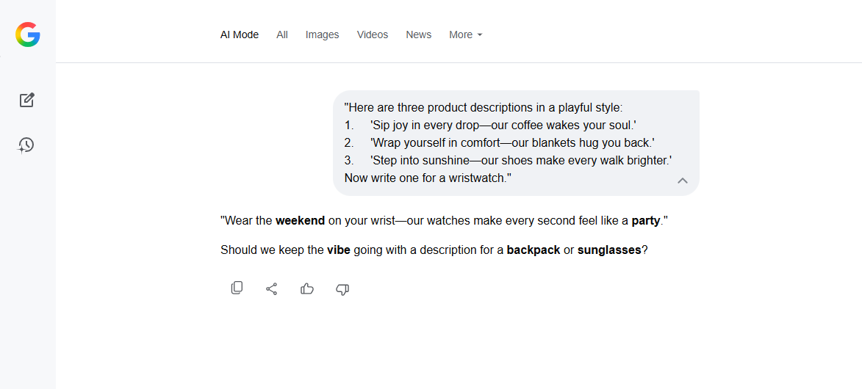

Question 4: System Prompting
Write a set of main rules for an Al. Tell it how it must always behave, what things it is not allowed to say, and what kind of tone it should use when talking to customers.
Answer 4: System Prompting
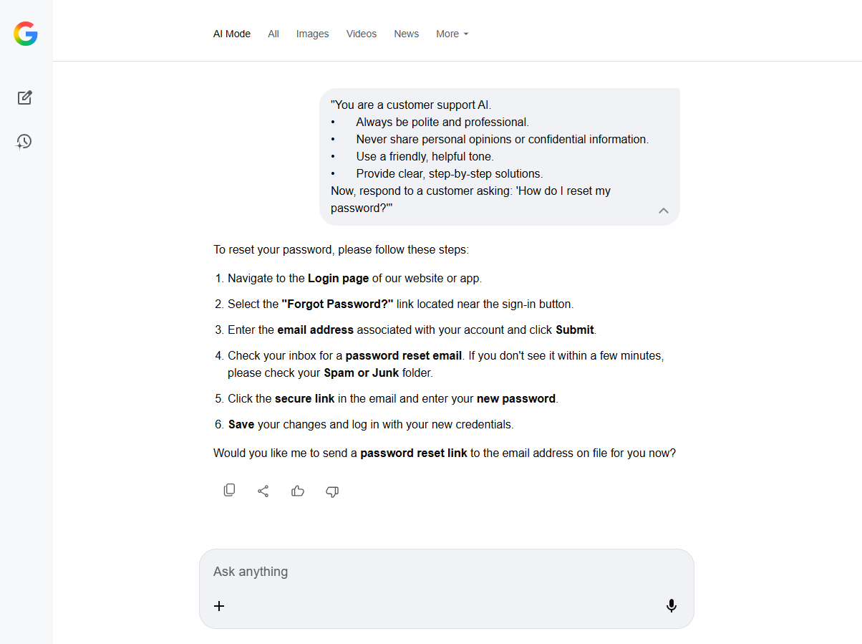

Question 5: Role Prompting
Write a prompt that tells the Al to act like a professional expert, such as a doctor, a lawyer, or a history teacher. Ask it a question that only someone in that job would know how to answer well.
Answer 5: Role Prompting
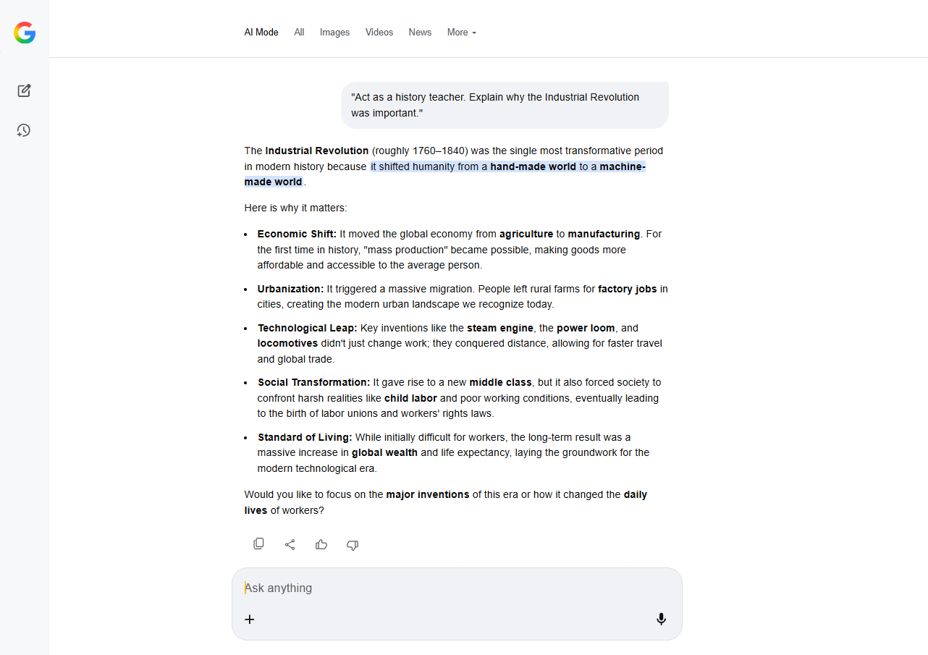

Question 6: Contextual Prompting
Write a prompt that gives the Al a lot of extra information first, such as facts about a business or a specific problem. Then, ask the Al to create a plan based only on the information you provided.
Answer 6: Contextual Prompting

